**Proof of Concept**

**ME 460**

**4 October 2019**

**Team STRESSED**

**List of Figures**

Figure 1: Ring-Plug Assembly Radii 5

Figure 2: Contact Pressures in Assembly 5

Figure 3: 3-D Plot for Outer Radius [1-6"] 8

Figure 4: 3-D Plot for Outer Radius [1.5-3"] 8

**List of Tables**

Table 1: Prop. Constant γ vs. [0.5-20"] Outer Radius 9

Table 2: Prop. Constant γ vs. [0.1-3"] Outer Radius 10

Table 3: Top 10 Designs & Parameters 12

Table 4: Minimum Interference Tolerance Stress Parameters 13

Table 5: Nominal Interference Tolerance Stress Parameters 13

Table 6: Maximum Interference Tolerance Stress Parameters 13

To achieve a desired residual stress in a material, the idea of shrink fitting is introduced. Shrink fitting is a commonly used practice where the thermal expansion and contraction due to heating and cooling is used to assemble a part that would otherwise be impossible to assemble. Naturally, this creates a residual stress. The idea of shrink fitting two materials together in the form of a ring and a plug, while achieving the greatest interference without yielding of the two materials, has been theoretically proven and referenced in the textbook, *Intermediate Mechanics of Materials* by Madhukar Vable. The equations from this book are used to determine the pair of materials that, when shrink fitted, will provide a pressure at the interface that is equal to the elastic limit of the material. Rather than achieving the greatest interference without yielding, the objective is to use these formulas to create a design which will exhibit ring yielding at the interface. The desired goal is to have a ring-plug assembly where the above/equal to ring yield stress radially propagates through the ring, rather than just located at the interface. The process of solving this problem using mechanics of material methods is revealed below.

First, since there are no axial forces in the assembly, the problem is treated as one of plane stress. The plug experiences only external pressure from the ring, whereas the ring experiences only internal pressure from the plug. The formulas used below apply to the Octahedral Shear Stress Theory, or otherwise known as, Von Mises Stress Criterion (Vable, 2014, p. 275). This theory of failure is chosen because the only materials used in this assembly will be ductile materials. The loading of these materials will be static loading rather than cyclical, and the loading is biaxial, hoop and radial. For these reasons, the octahedral shear stress theory is used. The von mises stresses for the ring and plug are calculated by first determining the radial normal stress and tangential normal stress. The equations for radial normal stress and the tangential normal stress of the plug are as follows:

(1)

(2)

is known to be the contact pressure between the ring and plug. and R are the inner and outer radii of the plug, respectively. is chosen to be the radius in which the stresses are evaluated. Since the plug has no inner radius, simplification of the above equations yields the result:

(3)

(4)

The Von Mises stress is calculated in Eq. 5 which the book justifies being less than or equal to the elastic limit of the plug. This inequality is shown below:

(5)

The Von Mises stress is also calculated from the radial and tangential components of stress for the ring. From there, a relationship is revealed between the contact pressure and residual stress in the ring. Since the goal is to hit a target residual stress in the material, this relation can be used to find the contact pressure required to achieve yielding in the ring. The formulas for the stress components of the ring are as follow:

(6)

(7)

(8)

(9)

With these stress components, the Von Mises stress calculation is similar to Eq. 5. In this case, Pc is factored out and the rest of the algebra is condensed into a proportionality constant, γ.

(10)

For further calculation of max interference, the minimum Pc value between Eq. 5 and 10 is chosen. On assembly, the ring is always required to yield before the plug. For this to occur, the elastic limit of the ring must be less than or equal to that of the plug. When that condition is met, Eq. 10 will be the inequality used to find the maximum interference possible.

The optimal assembly dimensions are radii which result in the lowest contact pressure needed to achieve yielding at the ring-plug interface. To determine these optimal dimensions, ring and plug radii are selected from 0.1 to 6 inches.

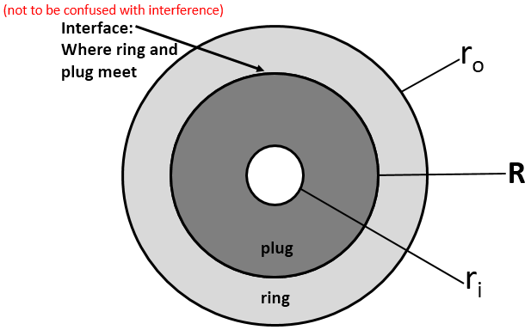

Figure 1: Ring-Plug Assembly Radii

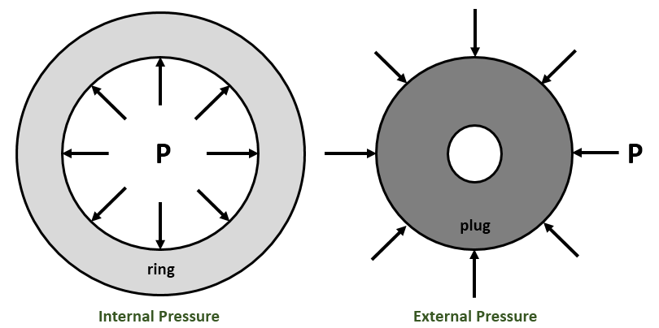

Figure 2: Contact Pressures in Assembly

From Lame’s Eq. 11, there is a relationship between material properties, dimensions, interference and pressure.

(11)

The goal is to achieve a desired residual stress in the assembly. As mentioned above, the Octahedral Shear Stress Theory can be used to relate pressure with residual stress. With these mathematical relations, finding the pressure required to achieve a desired residual stress at any desired radius is possible.

To start, the aim is for yield stress as the target residual stress and R as the desired radius. The maximum residual stress occurs at the point where, r = R (the interface) in Εqs. 1-10 above. When looking at Εqs.1-10, it is seen that , and are all proportional to P with proportionalities α, β and γ, respectively. It is important to notice that material properties aren’t necessary in calculating the residual stress (). Since the target stress is yield stress, it is desired to have:

(12)

(13)

This is where material properties are introduced! Once P is known, it can be plugged into Lame’s equation and radial interference can be solved for. To re-iterate, this interference will correspond to the pressure required for achieving yield stress at r = R, the interface.

As seen, residual stress () is independent of material properties and only depends on dimensions. It isn’t until the calculation of P that material properties are introduced. Thus, before exploring which material properties are optimal, first it is necessary to find out what combination of dimensions are optimal. The assumption is made that material properties are constant. In doing so Eq. 13 becomes:

(14)

Now, what value of P is optimal? Are larger P values better? Lower? The solution is simple. In Lame’s equation, the interference is proportional to the pressure P. For simplicity, the proportionality constant, φ, is introduced.

(15)

Where (16)

Large values of have implications on the assembly. Therefore, it is necessary to minimize for assembly purposes. For now, let φ be constant and the conclusion can be made that P needs to also be minimized.

  P 

Shortly, the idea of φ not being constant will be elaborated on. For now, proceeding back onto the relation

(17)

With this relation, γ, must be larger, in order to achieve a lower P under the given assumptions.

P  γ

To calculate what dimensions are optimal, all relations involving dimensions must be inspected. That is,and , respectively. Since γ is a function of and , it is unnecessary to examine and. The focus is primarily on and .

What happens to and more importantly, as dimensions are varied? View the figures below.

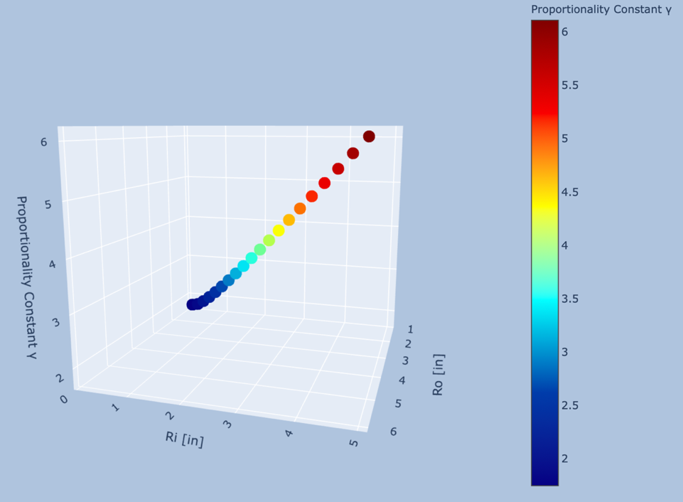

Figure 3: 3-D Plot for Outer Radius [1-6"]

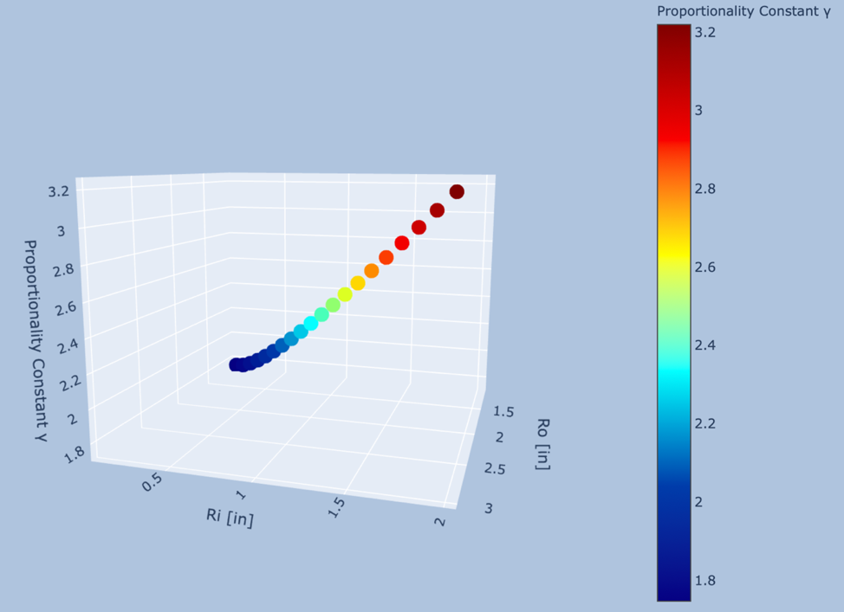

Figure 4: 3-D Plot for Outer Radius [1.5-3"]

So far, the analysis suggests that increasing R is ideal.

R

R

This is taken one step further by writing an algorithm that tries every possible dimensional pairs with a vector of values. An arbitrary span of 0.5in-20in is chosen. The table below is ordered in terms of the most important design parameter (minimizing ).

Table 1: Prop. Constant γ vs. [0.5-20"] Outer Radius

As seen, this is consistent with everything found up to this point, which is maximizing R, and having approach R, while still satisfying thick walled condition. Now, it is known what type of dimension combinations are optimal. Design constraints must be applied.

The idea is to hit a target residual stress, which in this case, is greater than or equal to . However, measuring this with strain gauges is needed. The details of this measurement are included in the strain gage study. To apply strain gauges, 1 inch minimum is required by the ring in thickness (. Another constraint is the ability to use photolithography with the design. Therefore, the second constraint is that the outer diameter must be less than or equal to 6 inches. From previous findings, it is concluded that the optimal dimensions would be and . To double check this, a reiteration of our algorithm was attempted, except with a span extending to only 3 in. radially. Also, the thick wall constraint was adjusted to accommodate for the strain gages. This design yields exactly what is needed which was at and .

Table 2: Prop. Constant γ vs. [0.1-3"] Outer Radius

Now having optimal dimensions, plugging in for gives:

(18)

(19)

(20)

Thus,

(21)

(22)

(23)

These relations hold true for all materials! Now, what materials/material properties are optimal? An optimization analysis was conducted, similar to what was previously done for dimensions. The relationship below is needed.

However, since the target residual stress is :

Since low P values are desired, it is concluded that low is also needed.

P  

Again, using an algorithm, optimum combinations of materials are arranged in a data frame. All possible permutation pairs of materials were run through the above equations and constraints were applied. At room temperature, the plug will not fit into the inner hole of the ring. Therefore, to shrink fit these two materials together, the inner diameter of ring needs to increase, and the plug’s outer diameter needs to decrease. Theoretically, to make this happen, the ring will be heated up and the plug will be cooled. The radial growth of the ring’s inner diameter and the reduction of the plug’s diameter abides by the equation below.2

Where α is the coefficient of thermal expansion of the material. R is the corresponding radii, and delta T is the difference in final temperature from initial temperature. This equation yields the maximum radial clearance for assembly. The data frame below reveals the optimal assembly configurations with inner radius of ring as 2 inches and outer radius of ring as 3 inches.

Table 3: Top 10 Designs & Parameters

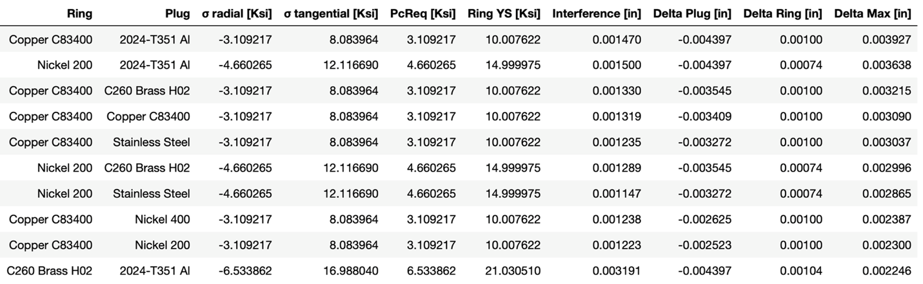

The material combinations in Table 3 are sorted by maximum “Delta Max [in].” This column displays the values which have the largest radial clearance possible at assembly. Since the Nickel 200 and 2024-T351 Aluminum combination is not only greater than constraint of having a clearance of at least 0.0015 diametric inches, but this combination would yield an assembly that has a bigger scale for equipment calibration. This can be seen from the “Ring YS [Ksi]” column where the Nickel 200 and 2024-T351 Aluminum combination has a residual stress of about 15 Ksi, versus the other top five combination which have about 10 Ksi of to yield. The C260 Brass H02 and 2024-T351 Aluminum combination has a larger yielding stress, however, is has a much lower radial clearance at assembly.

The interference values from Table 3 have too many significant figures of resolution for that interference value to be given to a machinist. Therefore, a ceiling round at the nearest thousandth of an inch was used, and by using Lame’s equation to perform back calculations, the required contact pressure to induce greater than yielding was found. From this required contact pressure, a larger than yield value is experience at the ring-plug interface. A ceiling round was performed rather than a floor round, so that way the back calculation would give a value which was not under the tensile strength of the ring material. The ceiling round is also beneficial as it ensures an above tensile strength stress to propagate further through the ring. This will ensure that the assembly meets the requirement of having at least a third of the ring at or above yielding stress. Since the tolerance for machining the assembly is , the nominal interference value for the design is chosen to be 0.003”. In this way, even if the assembly is machined with the most extreme tolerance for both the ring and the plug, the assembly will still exhibit the higher than the ring’s tensile strength stress values at the interface. The minimum, nominal, and maximum stress parameters are shown in Tables 4-6. This table is crucial for determining how the assembly will behave at extreme scenarios of dimension deviation along the tolerance band.

Table 4: Minimum Interference Tolerance Stress Parameters

Table 5: Nominal Interference Tolerance Stress Parameters

Table 6: Maximum Interference Tolerance Stress Parameters

References

1Vable, M. (2014). *Intermediate mechanics of materials*. Houghton, MI: Expanding Educational Horizons, LLC.

2Linear Thermal Expansion. (n.d.). Retrieved from https://www.engineeringtoolbox.com/linear-thermal-expansion-d_1379.html.